Project 24

Program Test Data
When testing an application is often a requirement to enter a set of test data and then determine that the program will act in the expected manner. In order to test these principles a program has been developed with known behaviour. Create a set of test data for this program for that program and from that determine what actions are being undertaken be the program. You will need to consider every action that could occur for the program. Try a number of actions like pressing keys, clicking and double clicking. Make a note of the behaviour in the table below.
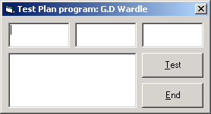
Item | Event | Action or Actions that occur for these events. Note any changes
Text Right hand top | Click
 | Key Press
 | Got Focus
 | Mouse Move
Text Middle top | Click
 | Key Press
 | Got Focus
 | Mouse Move
Text Left hand top | Click
 | Key Press
 | Got Focus
 | Mouse Move
Text Right hand bottom | Click
 | Key Press
 | Got Focus
 | Mouse Move
Test button | Click
 | Key Press
 | Got Focus
 | Mouse Move
End button | Click
 | Key Press
 | Got Focus
 | Mouse Move

Exercise
Try to reproduce the program. First produce the action plan and then write code.

